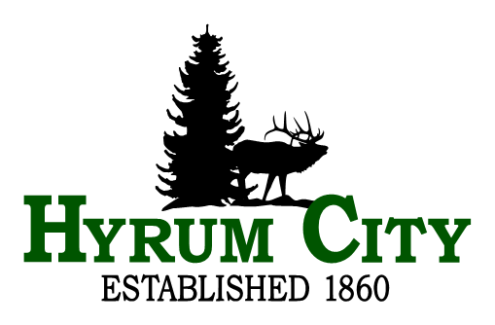
EMPLOYMENT OPPORTUNITY notice
HYRUM CITY is accepting resumes for a full time Level II Public Works Employee in the Culinary Water and Irrigation Department. Candidates will be required to work Monday through Friday from 7:00 a.m. to 3:30 p.m., with rotating on-call shifts, overtime, and available for emergency call outs.

Level II
- Must possess a Utah Water Distribution Classification Grade II or higher with a minimum of 2 years of experience in repairing water leaks and installing water lines.
- Must possess a Class B CDL.
- Must have a minimum of 4 years of experience: with a backhoe and excavating around utilities; and operating a dump truck, road grader, snow plow, and other miscellaneous heavy equipment.
- Knowledge of proper barricading and signage requirements.
- Must have a minimum of 1 year experience with chlorination systems, wells, and PRV stations.
- Proficient with GIS software and SCADA systems preferred.
- Requires ability to perform moderately heavy physical labor lifting upto 75 pounds and able to twist, kneel, and bend for associated tasks performed in the field.
- Ability to work in extreme hot and cold environmental conditions.
- Be available for snow removal from October through April.

This position may be filled at a level I by applicants who do not meet the requirements for level II.

Level I
- Must be able to obtain Utah Water Distribution Classification Grade II or higher within the first year of employment.
- Must possess or able to obtain a Class B CDL within the first year of employment.
- Must have a minimum of 2 years of experience in operating heavy equipment.
- Proficient with GIS software and SCADA systems preferred.
- Requires ability to perform moderately heavy physical labor lifting upto 75 pounds and able to twist, kneel, and bend for associated tasks performed in the field.
- Ability to work in extreme hot and cold environmental conditions.
- Be available for snow removal from October through April.

Upon employment employee must reside in Hyrum City or no further than fifteen miles from city office. Salary range is $25.75 to $29.87 per hour for Level II, or $19.57 to $24.72 per hour for Level I with full time benefits (health, dental, and life insurance, paid holidays, vacation and sick leave, and retirement). Send a cover letter and resume to Hyrum City Corporation, 60 West Main, Hyrum, UT 84319 or e-mail to stephanie.fricke@hyrumcity.gov. Resumes are accepted until the position is filled or withdrawn at the City’s discretion. A copy of the full position description is available at www.hyrumcity.org. EOE

Dated: December 20, 2024

