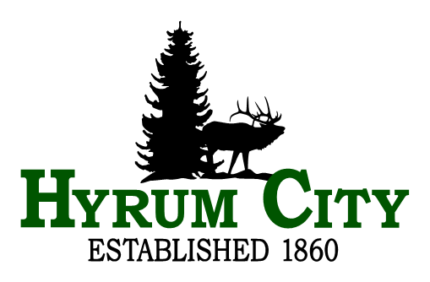

2025 notice of municipal election for hyrum city, utah

Notice is hereby given that Hyrum City will hold a Municipal Election this fall to elect a Mayor and two City Council Members. The Primary Election date is Tuesday, August 12, 2025 and the General Election date is Tuesday, November 4 2025. Hyrum City elections are non-partisan.

The Mayor and Municipal Council Members serve four-year terms and are elected at-large.

The incumbents are:
Mayor Stephanie Miller
Council Member Paul C. James
Council Member Jared L. Clawon

Anyone interested in filing for one of these offices must:
1. Be a United States citizen at time of filing
2. Be at least 18 years of age
3. Be a registered voter of Hyrum City
4. Be a resident of Hyrum City for at least 365 consecutive days immediately preceding the date of the election
5. Not be a convicted felon

Persons desiring to be candidates for the 2025 Hyrum City Municipal Election must file a declaration of candidacy form or nomination petition between, Monday, June 2, 2025 and Monday, June 9, 2025, at the City Recorder’s Office, 60 West Main, Hyrum, Utah weekdays between the hours of 8:00 a.m. and 5:00 p.m. The filing form is available at the City Recorder’s Office. Hyrum City requires individuals filing as candidates for the Hyrum City Council to pay a $25.00 fee at the time of filing (Res. 19-08).

Information regarding the election can be found on the city website at www.hyrumcity.gov under “Government” then “Elections”.

If you need additional information or have questions, please contact Hyrum City Recorder Stephanie Fricke at 435-245-6033, or by email stephanie.fricke@hyrumcity.gov.

________________________
Stephanie Fricke
City Recorder

